**1.Modelo RF5_Indeg Apoio Spe Diq Cint X All var**.

***Instrucciones modelo***: **test size = 0.17 ; rd_state = 30**

***Variables indep select to fit***:

variables = [ 'id', 'Indeg_IntimAmigos_',  'Indeg_RedeRisk_Cen', 'PC1_Distance_Pro', 'Degree_RedeTotFamil', '1_VarExp_Moranca', '2_VarExp_Atri_Tabanca']

***Model performance (scores):***

Mean Squared Error: 1.1818

R^2 Score: 0.5601 (In Excel: R2 = 0.5601 ; y = 0.4274 X + 1.0539)

**Model tot:**

Mean Squared Error (MSE): 0.5194

Root Mean Squared Error (RMSE): 0.7207

Mean Absolute Error (MAE): 0.4419

R^2 Score: 0.772

Pearson Correlation: 0.8992

***Interactions***:

| **Interacción** | **Importancia** | **Dirección** |
| --- | --- | --- |
| 0 | (1_VarExp_Moranca, 2_VarExp_Atri_Tabanca) | 0.535744 | 0.015768 |
| 1 | (Indeg_IntimAmigos_, 2_VarExp_Atri_Tabanca) | 0.530883 | -0.010837 |
| 2 | (Degree_RedeTotFamil, 2_VarExp_Atri_Tabanca) | 0.495715 | 0.006976 |
| 3 | (PC1_Distance_Pro, 2_VarExp_Atri_Tabanca) | 0.452591 | -0.005249 |
| 4 | (Indeg_RedeRisk_Cen, 2_VarExp_Atri_Tabanca) | 0.408551 | 0.047054 |
| 5 | (Indeg_RedeRisk_Cen, 1_VarExp_Moranca) | 0.280659 | 0.048542 |
| 6 | (PC1_Distance_Pro, 1_VarExp_Moranca) | 0.280614 | -0.004812 |
| 7 | (Degree_RedeTotFamil, 1_VarExp_Moranca) | 0.260620 | 0.010572 |
| 8 | (PC1_Distance_Pro, Degree_RedeTotFamil) | 0.257576 | -0.005734 |
| 9 | (Indeg_IntimAmigos_, 1_VarExp_Moranca) | 0.216361 | -0.003766 |

***Key results****:*

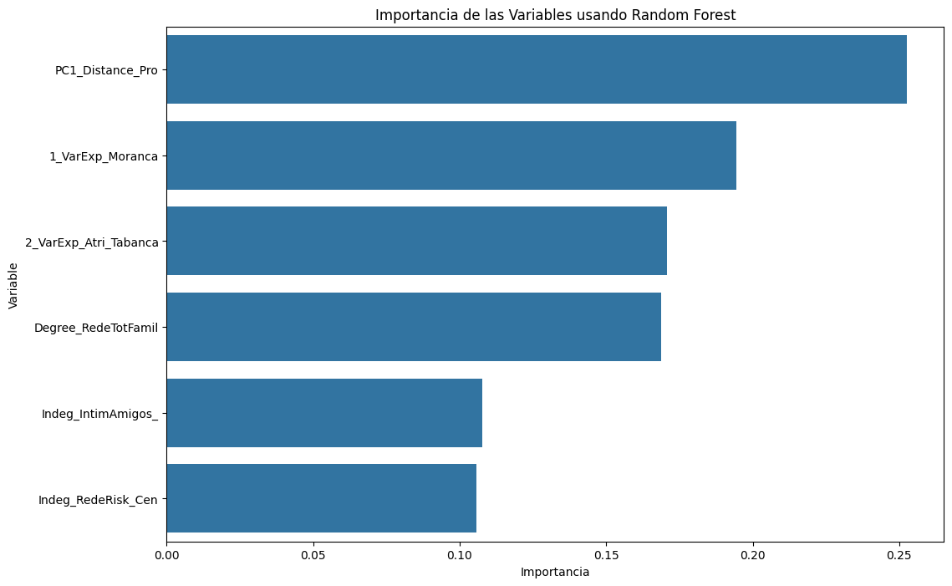

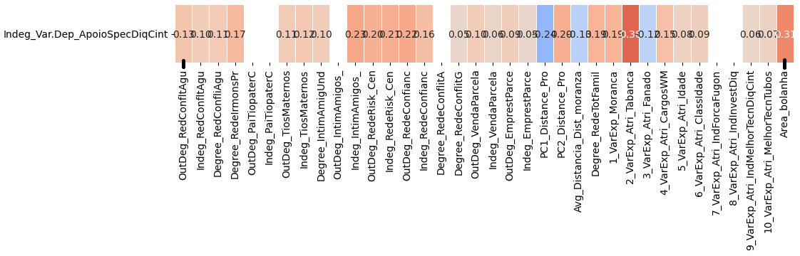

**2.Modelo RF5_Outdeg Apoio Spe Diq Cint X All var**.

***Instrucciones modelo***: **test size = 0.25, Rd_state = 8**.

***Variables indep select to fit***:

variables = ['id','Indeg_IntimAmigos_','Indeg_RedeRisk_Cen',

'Indeg_RedeConfianc', 'Degree_RedeTotFamil', '1_VarExp_Moranca', '4_VarExp_Atri_CargosWM', '7_VarExp_Atri_IndForcaFugon',

  '8_VarExp_Atri_IndInvestDiq','9_VarExp_Atri_IndMelhorTecnDiqCint', '10_VarExp_Atri_MelhorTecnTubos', 'OutDeg_RedeRisk_Cen']

***Model performance (scores):***

Mean Squared Error: 1.2121

R^2 Score: 0.8253 (on excel: **R2= 0.8683 ; Y = 1.0417 X + 0.1931**)

**Model tot:**

Mean Squared Error (MSE): 0.6977

Root Mean Squared Error (RMSE): 0.8353

Mean Absolute Error (MAE): 0.4031

R^2 Score: 0.9446

Pearson Correlation: 0.9740

***Interactions***:

| **Interacción** | **Importancia** | **Dirección** |
| --- | --- | --- |
| 0 | (Indeg_RedeConfianc, 9_VarExp_Atri_IndMelhorTe... | 3.118299 | 0.760584 |
| 1 | (Indeg_RedeConfianc, 10_VarExp_Atri_MelhorTecn... | 2.568799 | 0.753913 |
| 2 | (9_VarExp_Atri_IndMelhorTecnDiqCint, 10_VarExp... | 2.287380 | 0.407503 |
| 3 | (9_VarExp_Atri_IndMelhorTecnDiqCint, OutDeg_Re... | 2.219030 | 0.461888 |
| 4 | (Indeg_IntimAmigos_, Indeg_RedeConfianc) | 2.167837 | 0.152589 |
| 5 | (Indeg_RedeConfianc, 4_VarExp_Atri_CargosWM) | 2.136781 | 0.801694 |
| 6 | (Indeg_RedeConfianc, 1_VarExp_Moranca) | 2.134572 | 0.800102 |
| 7 | (Indeg_RedeRisk_Cen, Indeg_RedeConfianc) | 2.131173 | 0.016360 |
| 8 | (Indeg_RedeConfianc, OutDeg_RedeRisk_Cen) | 2.129254 | 0.795908 |
| 9 | (Indeg_RedeConfianc, 8_VarExp_Atri_IndInvestDiq) | 2.128635 | 0.795651 |

***Key results****:*

